Project Design Phase
Solution Architecture

Date | 27 June 2026
Team ID: RH-2026 | RH-2026
Project Name: RentalHouse | RentalHouse
Maximum Marks | 4 Marks

Solution Architecture:
Solution architecture is a complex process – with many sub-processes – that bridges the gap between business problems and technology solutions. Its goals are to:
- Find the best tech solution to solve existing business problems.
- Describe the structure, characteristics, behavior, and other aspects of the software to project stakeholders.
- Define features, development phases, and solution requirements.
- Provide specifications according to which the solution is defined, managed, and delivered.

RentalHouse System Architecture Diagram (Light Theme):
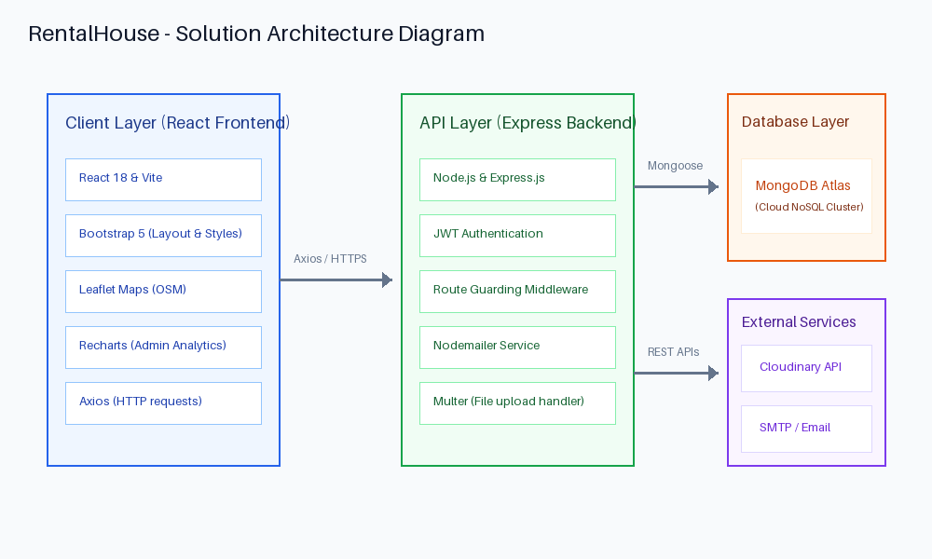


Figure 1: System Architecture and Data Flow of the RentalHouse Platform
Reference: Local MERN Stack Architecture Specifications

